SIMATS ENGINEERING

SAVEETHA INSTITUTE OF MEDICAL AND TECHNICAL SCIENCES

CHENNAI-602105

CSA0839 – PYTHON PROGRAMMING FOR CYBER SECURITY

Submitted By :S. Jaswanth Venkata Rahul

1)

numbers = []

while True:

num = int(input("Enter a number (-1 to exit): "))

if num == -1:

break

numbers.append(num)

positive_numbers = [n for n in numbers if n > 0]

negative_numbers = [n for n in numbers if n < 0]

avg_positive = sum(positive_numbers) / len(positive_numbers) if positive_numbers else 0

avg_negative = sum(negative_numbers) / len(negative_numbers) if negative_numbers else 0

print(f"Avg negative number is {avg_negative}, avg positive number is {avg_positive}")

2)

# Function to calculate square and cube of a decimal number

def calculate_square_and_cube(number):

square = number ** 2

cube = number ** 3

return square, cube

# Input

given_number = 0.6

# Calculation

square_number, cube_number = calculate_square_and_cube(given_number)

# Output

print(f"Square Number: {square_number}")

print(f"Cube Number: {cube_number}")

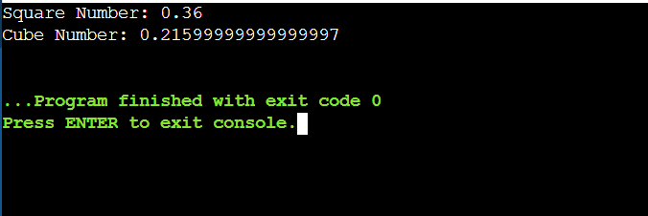

3)

# Pattern Printing Program

char = input("Enter the Character to be printed: ")

rows = int(input("Number of rows: "))

for i in range(1, rows + 1):

print((char + ' ') * i)

4)

A = 7

B = 5

for i in range(1, B + 1):

print(f"{A} x {i} = {A * i}")

5)

# Leap Year Checker

def is_leap_year(year):

if (year % 4 == 0 and year % 100 != 0) or (year % 400 == 0):

return "Leap Year"

else:

return "Not a Leap Year"

# Sample Input

year = 2000

print(is_leap_year(year))

6)

# Duplicate Array Finder

def find_duplicates(array):

return list(set(array))

# Sample Input

array = {1, 2, 3, 4, 1}

# Output

duplicate_array = find_duplicates(array)

print("duplicate array =", duplicate_array)

7)

# Check whether the number is positive or negative

number = 23

if number > 0:

print("positive")

elif number < 0:

print("negative")

else:

print("zero")

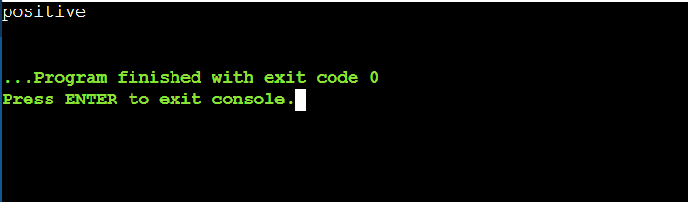

8)

# Average of Mean, Median, and Mode

import statistics

def calculate_average(data):

mean = statistics.mean(data)

median = statistics.median(data)

mode = statistics.mode(data)

average = (mean + median + mode) / 3

return average

data = [12, 45, 83, 52]

average_result = calculate_average(data)

print(average_result)

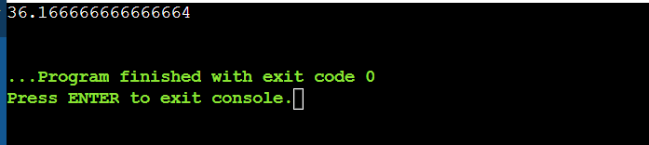

9)

# Store the arrays in non-increasing order

def sort_non_increasing(arr):

return sorted(arr, reverse=True)

# Sample Input

input_array = [1, 8, 3, 4, 0]

# Output

output_array = sort_non_increasing(input_array)

print(output_array)

10)

# Intersecting elements in two tuples

def intersect_tuples(tuple1, tuple2):

return tuple(set(tuple1) & set(tuple2))

# Sample Input

tuple1 = (2, 3, 4, 5)

tuple2 = (3, 4, 8, 6)

# Output

result = intersect_tuples(tuple1, tuple2)

print(result)

